**JAVA PROGRAMMING LAB**

**BASIC PROGRAMS Date: 15.07.2020**

R Narayan

19BCE0758

1. Read the radius and print the area of a circle

Ans:

Code:

import java.util.Scanner;

public class Circle

{

public static void main(String[] args)

{

int r;

double pi = 3.14, area;

Scanner s = new Scanner(System.in);

System.out.print("Enter radius of circle:");

r = s.nextInt();

area = pi * r * r;

System.out.println("Area of circle:"+area);

}

}

Output:

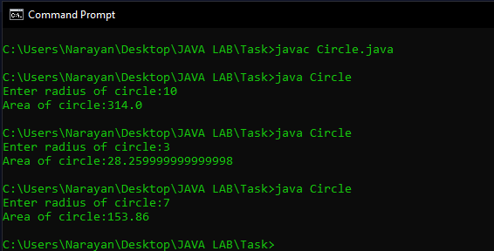

1. Read the number and check whether it is divisible by 3 and 5.

Ans:

Code:

import java.util.Scanner;

class Divisibility{

public static void main(String [] args)

{

System.out.println("Enter a number");

Scanner s = new Scanner(System.in);

int a;

a = s.nextInt();

if(a%15 == 0){

System.out.println("yes divisible by 3 and 5\n");

}

else{

System.out.println("not divisible by 3 and 5\n");

}

}

}

Output:

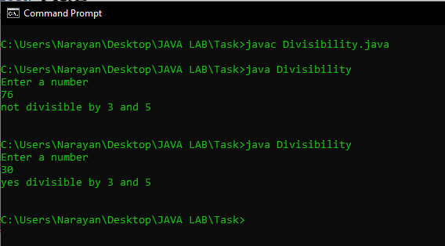

1. Display Subject Name based on room number. If the user enters 604 then display Java Programming , If the user enters 605 then display Python programming for any other input display Invalid input to the user

Ans:

Code:

import java.util.Scanner;

class Labroom{

public static void main(String [] args){

System.out.println("Enter the lab No");

Scanner s = new Scanner(System.in);

int a;

a = s.nextInt();

if(a == 604){

System.out.println("Java Programming Lab");

}

else if(a == 605){

System.out.println("Python programming lab");

}

else{

System.out.println("Invalid Input");

}

}

}

Output:

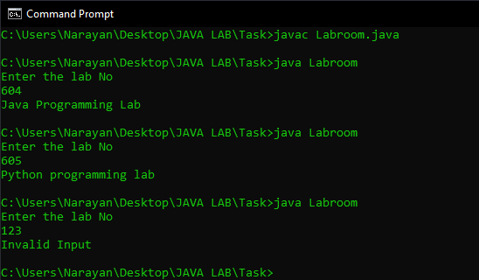

1. Print the sum of first n numbers. If n is 3 then print the sum of 1+2+3 to the user. Get n from the user

Ans:

Code:

import java.util.Scanner;

class Series1{

public static void main(String [] args){

System.out.println("Enter a No");

Scanner s = new Scanner(System.in);

int a,sum=0;

a = s.nextInt();

for(int i = 1; i<a+1;i++){

sum = sum + i;

}

System.out.print("Sum is ");

System.out.println(sum);

}

}

Output:

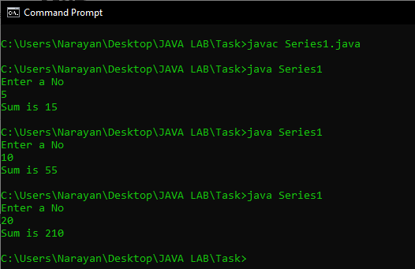

1. Print the sum of the series 12+22+32 up to n terms

Ans:

Code:

import java.util.Scanner;

class Series2{

public static void main(String [] args){

System.out.println("Enter a No");

Scanner s = new Scanner(System.in);

int a,sum=0;

a = s.nextInt();

for(int i = 1; i<a+1;i++){

sum = sum + i*i;

}

System.out.print("Sum is ");

System.out.println(sum);

}

}

Output:

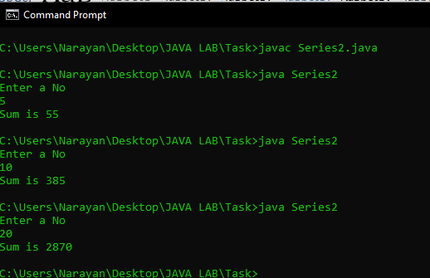

1. Print the multiplication table by getting the n from the user.

Ans:

Code:

import java.util.Scanner;

class Mtable{

public static void main(String [] args)

{

System.out.println("Enter the number");

Scanner s = new Scanner(System.in);

int a;

a = s.nextInt();

for(int i = 1; i<11; i++){

System.out.print(i);

System.out.print(" X ");

System.out.print(a);

System.out.print(" = ");

System.out.println(a*i);

}

}

}

Output:

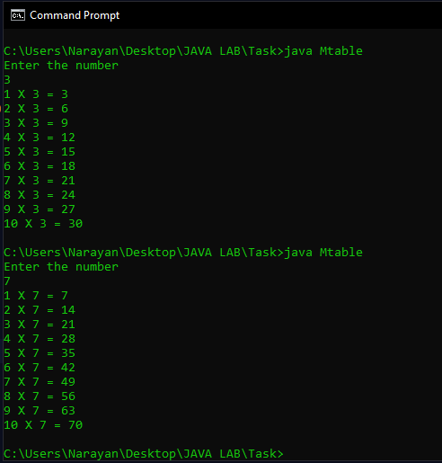

1. Provide the option of adding two numbers to the user until the user wants to exit.

Ans:

Code:

import java.util.Scanner;

class Calc{

public static void main(String [] args){

Scanner s = new Scanner(System.in);

int a = 0;

do{

System.out.println("\n\t\tMenu\n\t1.add\n\t2.exit\n\tSelect an option");

a = s.nextInt();

if(a == 1){

int n1,n2;

System.out.println("Enter First No");

n1 = s.nextInt();

System.out.println("Enter Second No");

n2 = s.nextInt();

System.out.println("Sum is ");

System.out.println(n1+n2);

}

else if(a != 2){

System.out.println("Invalid Input");

}

}while(a != 2);

}

}

Output:

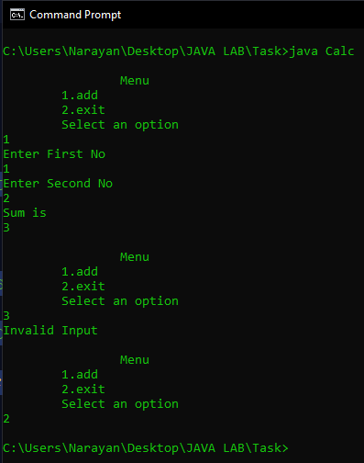

8. Print this pattern for n lines

(a)

*

**

***

****

(b)

1234

123

12

1

(c) 1

12

123

1234

1234

123

12

1

Ans:

Code:

import java.util.Scanner;

class Patterns {

public static void main(String [] args){

Scanner s = new Scanner(System.in);

int a = 0;

do{

System.out.println("\n\t\tMenu\n1.Pattern a\n2.Pattern b\n3.Pattern c\n4.Exit\nSelect an option\n");

a = s.nextInt();

if(a == 1){

int n;

System.out.println("Enter n");

n = s.nextInt();

for(int i = 1;i < n+1;i++){

for(int j = 0; j < i; j++){

System.out.print("*");

}

System.out.print('\n');

}

}

else if(a == 2){

System.out.println("Enter n");

int n;

n = s.nextInt();

for(int i = n; i>0; i--){

for(int j = 1; j<i+1; j++){

System.out.print(j);

}

System.out.print('\n');

}

}

else if(a == 3){

System.out.println("Enter n");

int n;

n = s.nextInt();

for(int i = 1; i<n+1; i++){

for(int j = 1; j<i+1; j++){

System.out.print(j);

}

System.out.print('\n');

}

for(int i = n; i>0; i--){

for(int j = 1; j<i+1; j++){

System.out.print(j);

}

System.out.print('\n');

}

}

else if(a != 4){

System.out.println("Invalid Choice");

}

}while(a != 4);

}

}

Output:

